**EasyGradeXL**

User manual

horizontal line

Contents

License Agreement 3

About EasyGradeXL 4

System requirements 4

Getting started 4

Obtaining Google credential key 4

Downloading and installing 5

Language settings 5

Audio settings 7

Entering marks or grades 7

The EasyGradeXL Window 10

The Enter Marks Section 11

Entering Marks and/or Grades 12

Colors and Sounds 14

The Entry Logger Section 14

Using the entry log 15

The Settings Worksheet 15

Speech Settings 15

Common phrases 16

General settings 17

# License Agreement

Copyright (c) 2021 Tony L. Jones

Permission is hereby granted, free of charge, to any person obtaining a copy of this software and associated documentation files (the “Software”), to deal in the Software without restriction, including without limitation the rights to use, copy, modify, merge, publish, distribute, sublicense, and/or sell copies of the Software, and to permit persons to whom the Software is furnished to do so, subject to the following conditions:

The above copyright notice and this permission notice shall be included in all copies or substantial portions of the Software.

THE SOFTWARE IS PROVIDED “AS IS”, WITHOUT WARRANTY OF ANY KIND, EXPRESS OR IMPLIED, INCLUDING BUT NOT LIMITED TO THE WARRANTIES OF MERCHANTABILITY, FITNESS FOR A PARTICULAR PURPOSE AND NONINFRINGEMENT. IN NO EVENT SHALL THE AUTHORS OR COPYRIGHT HOLDERS BE LIABLE FOR ANY CLAIM, DAMAGES OR OTHER LIABILITY, WHETHER IN AN ACTION OF CONTRACT, SORT OR OTHERWISE, ARISING FROM, OUT OF OR IN CONNECTION WITH THE SOFTWARE OR THE USE OR OTHER DEALINGS IN THE SOFTWARE.

# About EasyGradeXL

EasyGradeXL is an MS Excel workbook with additional functionality that simplifies the tedious task of manually entering student’s marks or grades. By using speech recognition, marks can be entered at a much faster rate. EasyGradeXL also keeps a log of the order in which grades were entered. This log makes it easy to check that the grades were entered correctly

EasyGradeXL is free open-source software. Its aim is to lighten the workload of teachers and support staff at educational institutions.

# System requirements

This version of EasyGradeXL requires MS Windows 64. It was developed and tested on MS Excel 2018. It may be made available for other platforms in the future.

# Getting started

### Obtaining Google credential key

EasyGradeXL makes use of Google speech-to-text. Please follow the instructions at the following link to create a JSON credential key:

<https://cloud.google.com/speech-to-text/docs/before-you-begin>

Make sure that you enable both the **Cloud Speech-to-Text** and **Text-to-Speech** Google Application Programming Interface (API).

Download the JSON credential key file and save it on your computer. We recommend that you save it in your User Folder.

Please note that the **Cloud Speech-to-Text** and **Text-to-Speech** are not free. Please familiarize yourself with the cost structure and set quotas.

### Downloading and installing

Download the latest installer from <https://sourceforge.net/projects/easygradexl/>

Run the EasyGradeXLInstaller and follow the instructions.

Near the end of the installation, you will be asked to select a folder to save the file *GradeBook.xlsm*, as shown below:

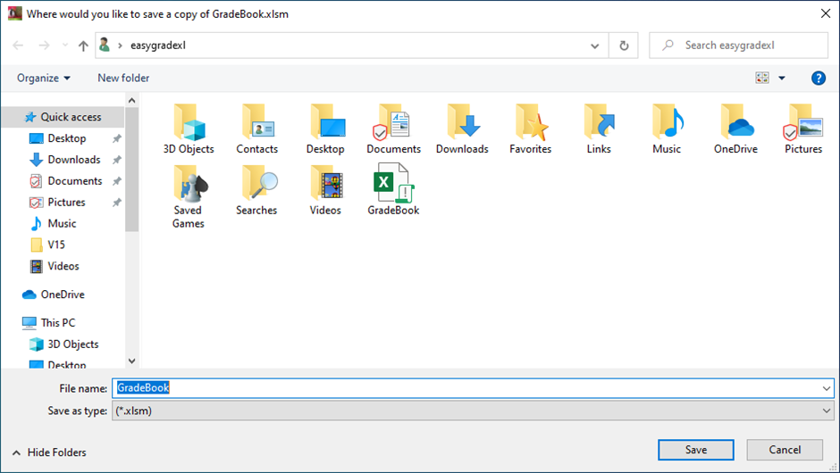

You may select any folder to which your user has write access. The file *GradeBook.xlsm* should be seen as a template. Please make a copy of this file each time you want to create a new workbook.

Note that EasyGradeXL is **not** an Excel add-in. It is an Excel workbook.

### Language settings

Open the GradeBook.xlsm file with Microsoft Excel and select the *Settings* sheet.

Go to the *Speech Settings* column and select Speech-to-text language from the dropdown list. This list contains all the languages that are supported by the Google speech-to-text API at the time of publishing. It is very important that you select the language that matches your accent. The Google Cloud speech-to-text service usually provides accurate results if you choose the correct accent.

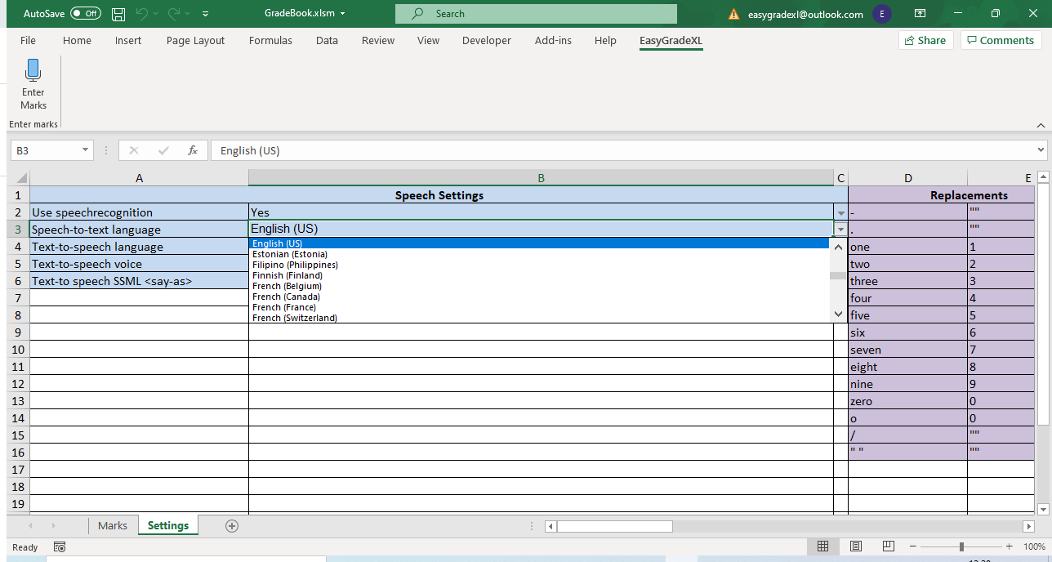

Next select the Text-to-Speech language dropdown list:

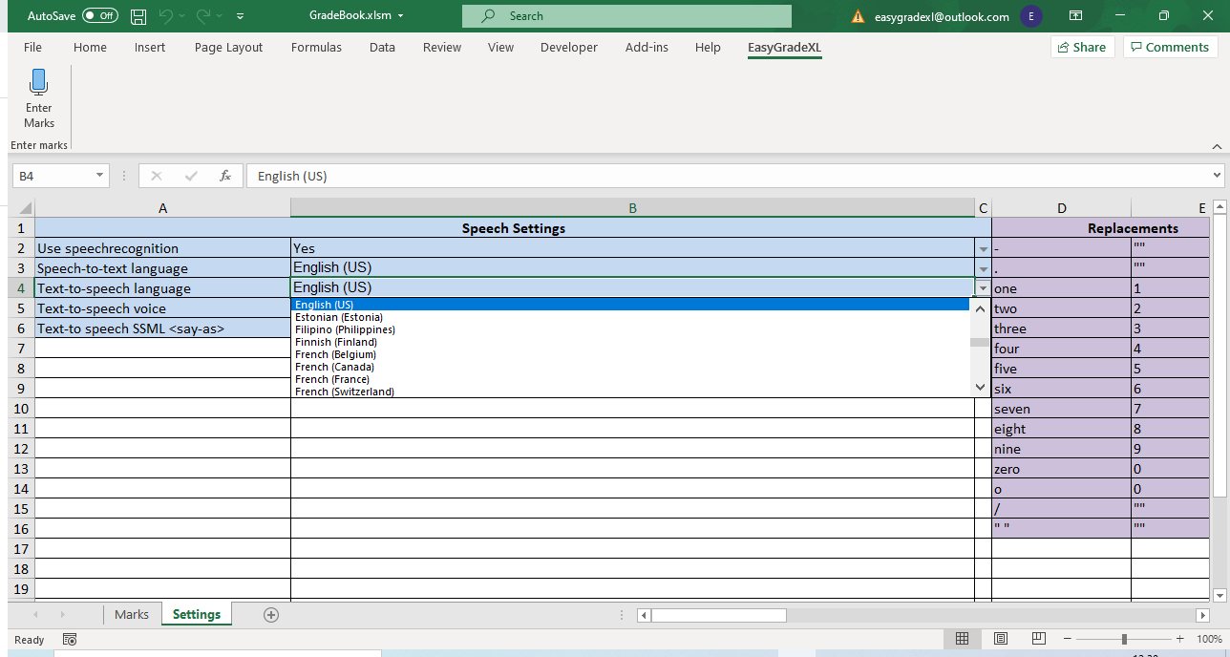

Select a text-to-speech voice from the dropdown list. This list will contain all the voices that are available for the selected language. The Google text-to-speech API does not yet support all languages. In this case the message *Not available* will appear and text-to-speech will be disabled.

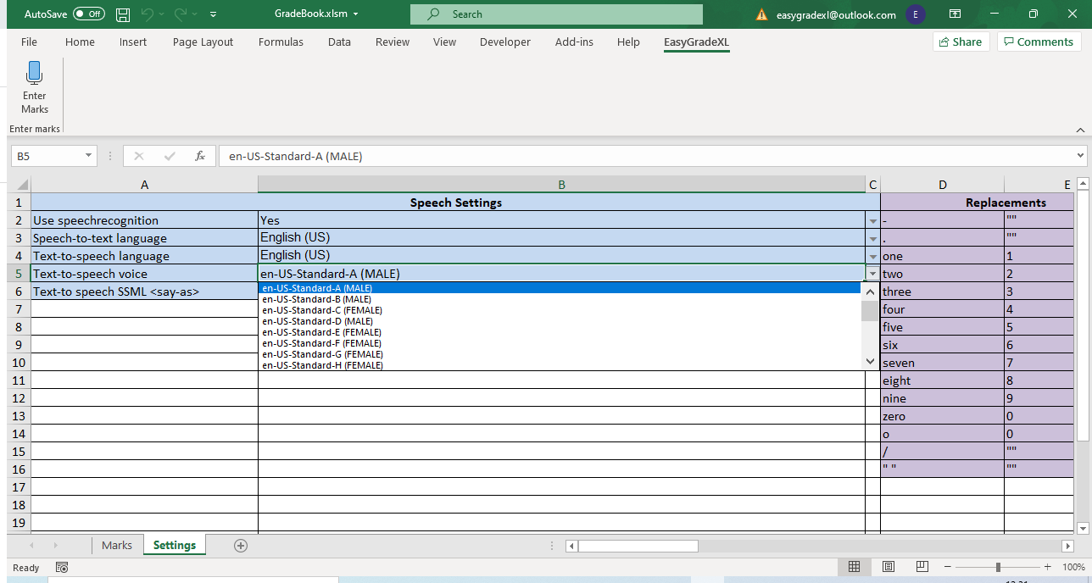

### Audio settings

EasyGradeXL uses the default Windows audio input and output devices. Please go to **Settings -> Sound** and make sure that your default audio input and output devices are set up correctly.

### Entering marks or grades

Select the *Marks* sheet. This sheet contains a list of fictitious student Identification Numbers (ID). You may replace these with a list of your class’s ID numbers. Click the *EasyGradeXL* menu on the ribbon. Click on the *Enter Marks* icon. The following window will appear:

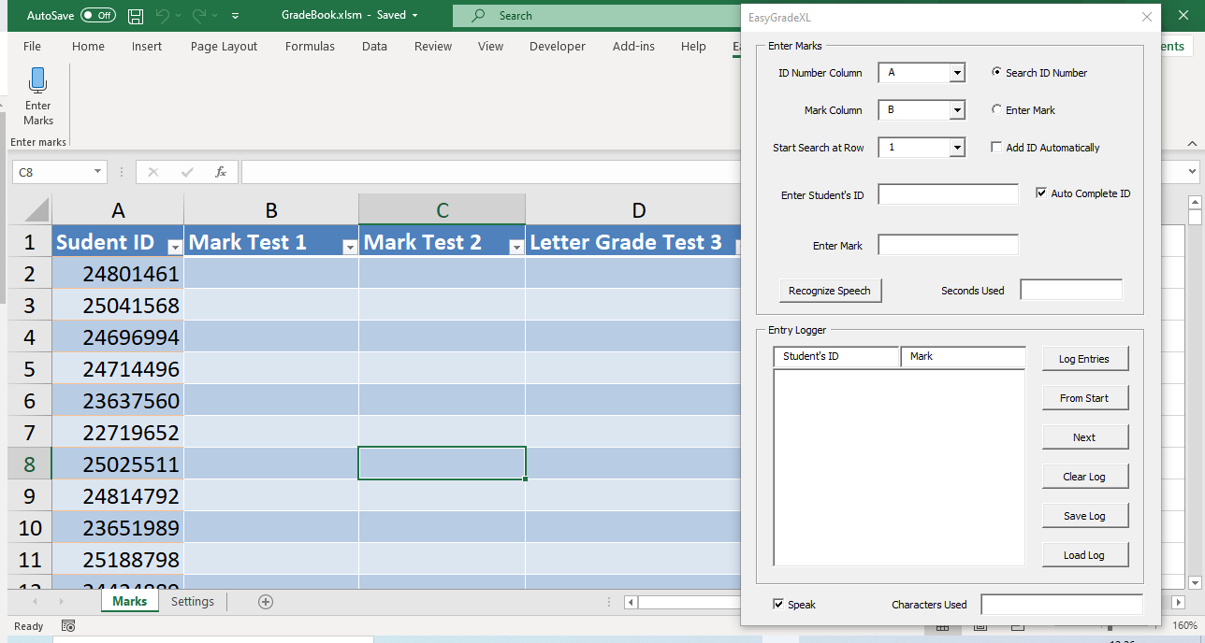

* Select the *ID Number column* from the dropdown list. On this sheet, the students’ ID numbers are in column A.
* Select the *Mark Column* from the dropdown list. On this sheet, the marks will be entered in column B.
* Select the *Start search at row* from the dropdown list. Rows above this row will be ignored when searching for ID numbers. In this sheet we will start searching at row 2.

Click the *Recognize Speech* and *Log Entries* buttons. The *Recognize Speech* button turns on speech recognition.

While the *Log Entries* button is on, a list of student ID numbers and Marks will appear in the *Entry logger* window. The entry log contains a list of ID numbers and marks in the order in which they were entered. This feature can later be used to check that the marks were entered correctly.

Say one of the ID numbers in column A. Try to speak clearly and take short pauses between reading numbers. EasyGradeXL will locate the student’s ID number and highlight the row containing it in blue.

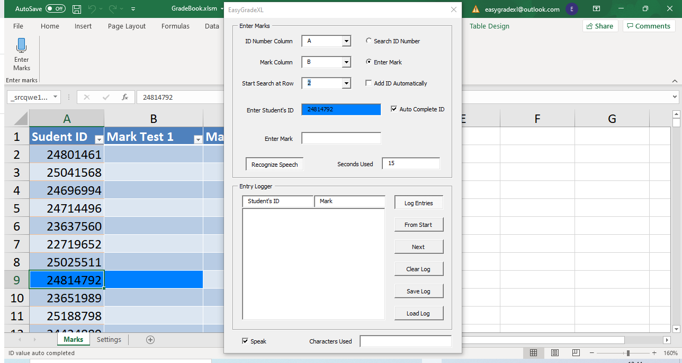

Now say the mark that should be assigned to this student. In this case it was 85.

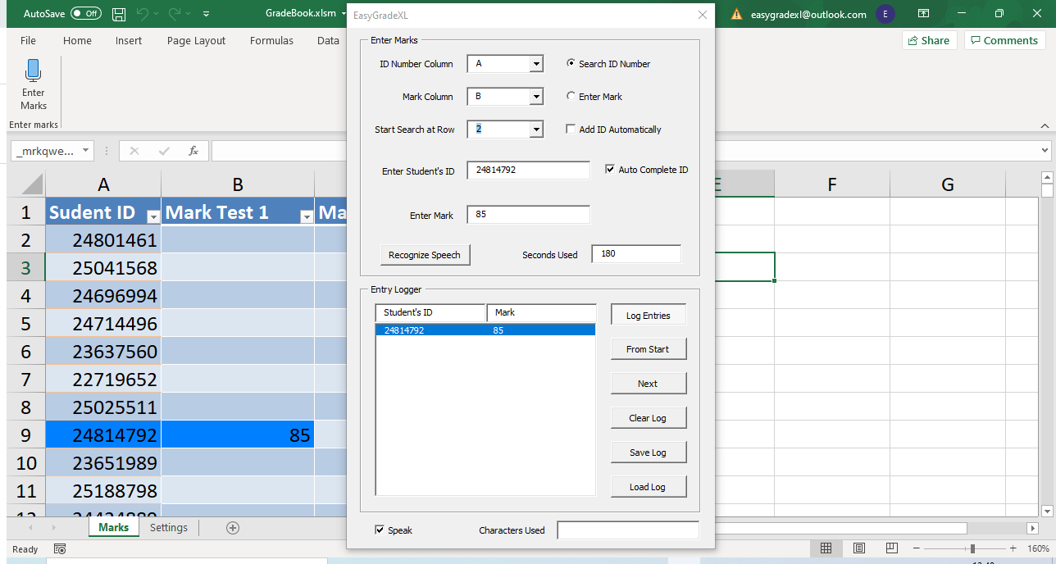

The mark is automatically entered in column B, next to the student’s ID number. The student’s ID and mark are displayed in the *Entry Logger* window. Enter a few more marks.

Notice how the indicator jumps between the *Search ID Number* and the *Enter Mark* labels.

* Press the *Recognize Speech* button to pause speech recognition.
* Now press the *From Start* button.

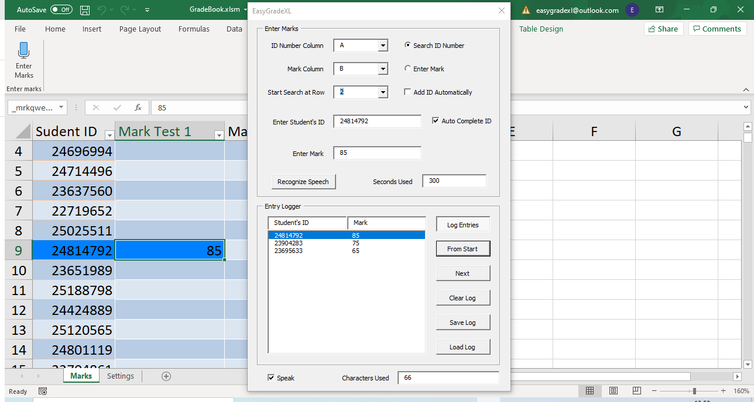

EasyGradeXL will start reading the ID numbers and marks in the entry log. It will also highlight the row containing the ID number and mark. Press the *Next* button to read back the next entry in the list.

This explains the basic functionality of EasyGradeXL. Please close the EasyGradeXL window and save the workbook, if required.

# The EasyGradeXL Window

This section provides a detailed description of each of the fields and buttons of the EasyGradeXL Window.

The window is divided into two sections:

* **Enter Marks:** This contains the tools for entering marks or grades. Marks can be entered by means of speech recognition, by using the keyboard or a combination of the two.
* **Entry Logger:** This keeps a log of the student’s ID numbers and grades in the order in which they are entered, thereby making it easy to check afterwards that the marks were entered correctly.

## The Enter Marks Section

* **ID Number Column:** Select the column that contains the students’ ID numbers from the dropdown list. EasyGradeXL will search this column to locate the (partially) entered ID number.
* **Mark Column:** Select the column into which the marks will be entered from the dropdown list.
* **Start Search at Row:** This is the number of the row at which the search for the ID number will start. The aim is to ignore headers when searching for ID numbers. For example: If the first row of the ID number column contains a header, then row 2 must be selected from the dropdown list in order to ignore the header row.
* **Search ID number:** This button indicates that an ID number is currently being entered and that the ID Number Columns is being searched for the location of the entered ID number. TBD
* **Enter Mark:** This button indicates that a mark is currently being entered in the Mark Column, in the same row as the selected ID number.
* **Add ID Automatically:** When selecting this option, ID numbers that were not found in the ID number column will automatically be added to the bottom of the list.
* **Auto Complete ID:** When selecting this option, EasyGradeXL will search for partially completed ID numbers and automatically complete the ID number once it has determined that the (partial) ID number is unique.
* **Enter student’s ID:** The student’s unique ID number (which may contain both letters and/or numbers) is entered in this box, either through speech recognition and/or by means of the computer’s keyboard.
* **Enter Mark:** After the student’s ID number has been entered and located**,** the student’s mark or grade is entered in this box, either through speech recognition and/or by means of the computer’s keyboard.
* **Recognize Speech:** This button turns speech recognition on or off. Make sure that you do not inadvertently leave this button in the on position.
* **Seconds Used:** Shows the number of seconds that was billed by the Google speech-to-text API. Please familiarize yourself with the cost associated with the use of this API.

# Entering Marks and/or Grades

Start by selecting the *Marks* sheet of the *GradeBook.xlms* workbook. The *Marks* sheet is an example sheet. You may edit it, delete its contents, or add new sheets of your own.

Press the *Enter Marks* button under the *EasyGradeXL* menu on the ribbon. This example sheet contains 350 fictional student ID numbers in column A.

To familiarize yourself with the process, first leave the *Recognize Speech* button in the *Off* position. Make sure that *Auto Complete ID* is selected, and that *Add ID automatically* is unselected, as shown below:

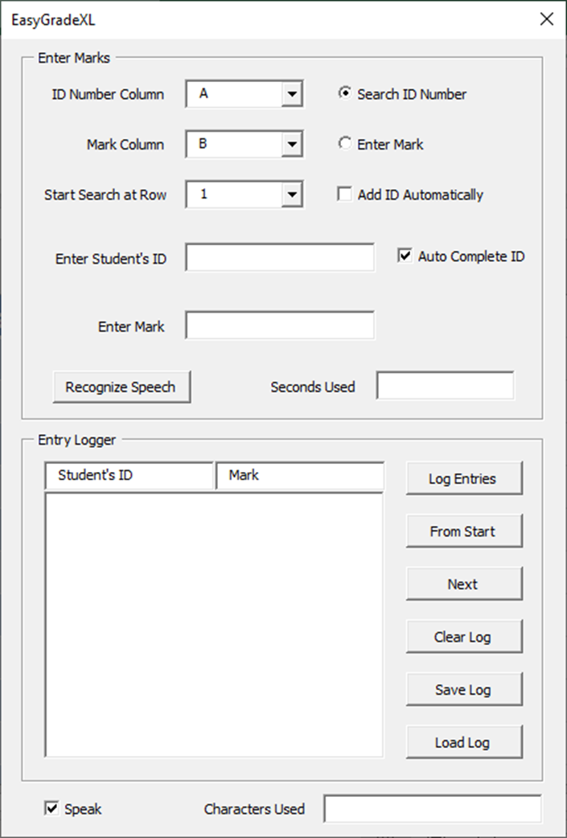

Start by typing one of the ID numbers in column A into the *Enter Student’s* ID box, for instance 24814792.

As soon as you type the number 2, the second row of the worksheet will be highlighted in light orange. The background of the *Enter Student’s ID* box will turn orange. This means that a partial ID number was found, but that there are more ID numbers starting with 2. Next type 481, next to the 2 you already entered. Row9 will be highlighted in light orange. This indicates that an ID number starting with 2481 was found, but it is not unique, i.e., there are more ID numbers starting with 2481 in column A. Now type 47. Row 9 will be highlighted in blue and 92 will automatically be added to auto-complete the ID number 24814792. Blue indicates that a unique ID number starting with 248147 was found in Column A. The clicking sound indicates that the ID number was automatically completed by EasyGradeXL. Deselecting the *Auto Complete* checkbox will disable the autocomplete feature.

Press the Tab or Enter key to move the cursor to the *Enter Mark* box and type the student’s marks for this assignment. Press the Tab or Enter key to move the cursor back to the *Enter Student’s ID* box.

The Enter and Tab keys behave in a slightly different way when entering a student’s ID. Pressing the Tab key will select the highlighted ID number, even if it was not uniquely identified and move the cursor to the *Enter Mark* box. Pressing the Enter key will only select ID numbers that have been uniquely identified. A noise will sound if the number is not uniquely identified when pressing enter.

For example: type 251in the Enter Student’s ID box. Row 11 will be highlighted in orange. Now press the tab key. The ID number in row 11 will be selected automatically, even though it was not uniquely identified. Enter a mark in the *Enter Mark box* and press enter or tab the cursor to the *Enter Student’s ID* box. Again type 251 into the *Enter Student’s ID* box. Row 11 will again be highlighted in orange. Now press the Enter key. You will hear a warning sound to indicate that the ID number was not uniquely identified.

#### Adding ID numbers automatically

When the *Add ID Automatically* checkbox is ticked, ID numbers that are not found are automatically added to the bottom of the ID Number column. Tick the *Add ID Automatically* checkbox and then type 123456 in the *Enter Student’s ID* box. The background color of this box will turn green to indicate that you are adding a new ID number. The new number will be added to the bottom of the ID Number column.

### Colors and Sounds

The following table summarizes the colors EasyGradeXL will display and sounds it will play under specific conditions:

|  |  |  |
| --- | --- | --- |
| **Condition** | **Color** | **Sound** |
| ID number not found | aaaaaa |  |
| ID Number not unique | aaaaaaaa |  |
| ID Number auto completed | aaaaaaaa |  |
| Non-unique ID Number selected by pressing Tab | aaaaaaaa |  |
| ID Number added automatically | aaaaaaaa |  |

## The Entry Logger Section

When entry logging is enabled, EasyGradeXL keeps a log of ID numbers and marks in the order in which they were entered. This log makes it easy to check that the grades were entered correctly. The premise is that user will start with a stack of answer sheets, enter the grades one by one, and then turn the stack over and start from the beginning to check that the grades were entered correctly.

The following is a description of the buttons and boxes in the *Entry Logger* section of the EasyGradeXL window:

* **Log Entries button:** This button turns entrylogging on or off.
* **Student’s ID and Mark box:** When entry logging is turned on, this box displays a list of student ID numbers and marks in the order in which they were entered.
* **From Start button:** Press this button to select the first entry in the list.
* **Next:** Press this button to select the next entry in the list.
* **Clear log:** This button clears the entry log.
* **Save log:** Saves the entry log to a hidden sheet in the workbook.
* **Load log:** Loads the previously saved entry log.
* **Speak:** Check this box to enable text-to-speech. When enabled, the ID numbers and marks will be read aloud.
* **Characters used:** This box displays the number of characters that was used by the Google Cloud Text-to-Speech API to readback entries.

### Using the entry log

Turn entry logging on by clicking the *Log Entries* button. Enter a few grades, like we did in the previous section. The ID numbers and grades will show in the *entry log*. Click the *From start* button. The row in which the entry is located will be highlighted and the ID number and marks will be read out in the language and voice you selected under *Text-to-speech settings* in the Settings sheet. You can disable the text-to-speech feature by unchecking the *Speak* checkbox in the bottom left corner.

Click next to read the next entry in the list.

You can edit entries in two different ways:

1. By editing the values in the *Enter Student’s ID and Enter Mark* textboxes.
2. By editing the values in the worksheet, itself. Please keep in mind that Microsoft Excel enters a blocking mode when editing the value of a cell. Press Enter after you have finished editing a cell for EasyGradeXL to resume its normal operating mode.

An entry that has been edited will automatically be moved to the bottom of the list of entries.

Save the entry log if you need to recheck your marks at a later stage.

# The Settings Worksheet

### Speech Settings

Select each of the speech settings from the dropdown lists in this column.

1. *Use speech recognition*: Select *Yes* if you want to use speech recognition. Using speech recognition requires a Google Cloud API key, as described in the *getting started* section.
2. *Speech-to-text language:* Choose the language you will speak when entering marks. The dropdown list contains all the languages which the Google Cloud Speech-to-text API supports. It is very important that you correctly choose your local dialect in order to get accurate speech-recognition results.
3. *Text-to-speech language:* This is the language in which EasyGradeXL will read back log entries. Using the text-to-speech feature also requires a Google Cloud API key.
4. *Text-to-speech voice:* Choose the voice in which EasyGradeXL will read back log entries. If no voices are available for your language, it means that the Google Cloud API does not yet offer text-to-speech in your language. In this case the text-to-speech feature will be disabled.
5. *Text-to-speech SSML <say-as>*: We suggest that you leave this setting on *verbatim*. You can read more about this setting at the following link: <https://cloud.google.com/text-to-speech/docs/ssml>

#### Replacements

Column *D* contains a list of words or symbols which EasyGradeXL will automatically replace in text received from the Google Cloud text-to-speech API. Words and symbols in column D will be replaced by those in column E. You may modify this list to fit your needs. Please do not leave any empty rows because EasyGradeXL will ignore replacements after an empty row.

### Common phrases

Column *F* contains a list of common phrases. The list of phrases improves the accuracy of the speech recognition. You may modify this list to fit your needs. Please do not leave any empty rows because EasyGradeXL will ignore phrases after an empty row.

### General settings

#### Maximum number of rows

The default value is 1000. This means that EasyGradeXL will only search for ID Numbers up to row 1000. You may change this number if your class has more than 1000 students.

#### Maximum number of columns

The default value is 100. You may increase this value if you use more than 100 columns on a single worksheet.

#### Path to Google speech API credentials

The path to your Google Cloud API credentials file. This should be set up correctly if you used the EasyGradeXL installer.

#### Path to GradeBook.exe

EasyGradeXL consists of a spreadsheet as well as a (frozen) Python application. This cell contains the path to the Python application. The path should be set up correctly if you used the EasyGradeXL installer.

#### Default ID column

This is the default ID number column that will be selected by EasyGradeXL.

#### Default Mark column

This is the default mark column that will be selected by EasyGradeXL. Note that the ID and mark columns may not be the same.

#### Default Row at which to start search

The default value is set to 2. This means that the first row will be ignored when searching for ID numbers.